Section B — Practical Configuration Tasks

Task-1.Configure Management and Staff VLANs Set up two VLANs on a Cisco switch to logically separate startup departments. (Foundational — single concept, direct configuration.) Create VLAN 10 named Management and VLAN 20 named Staff on the switch. Assign specific access ports to each VLAN. Verify the VLAN assignments using show vlan brief.
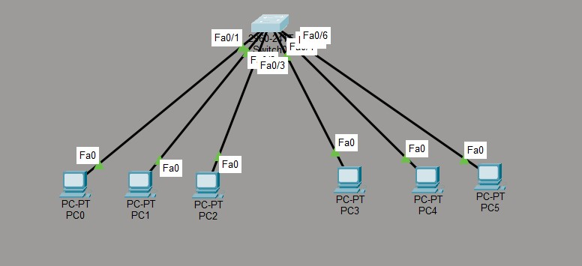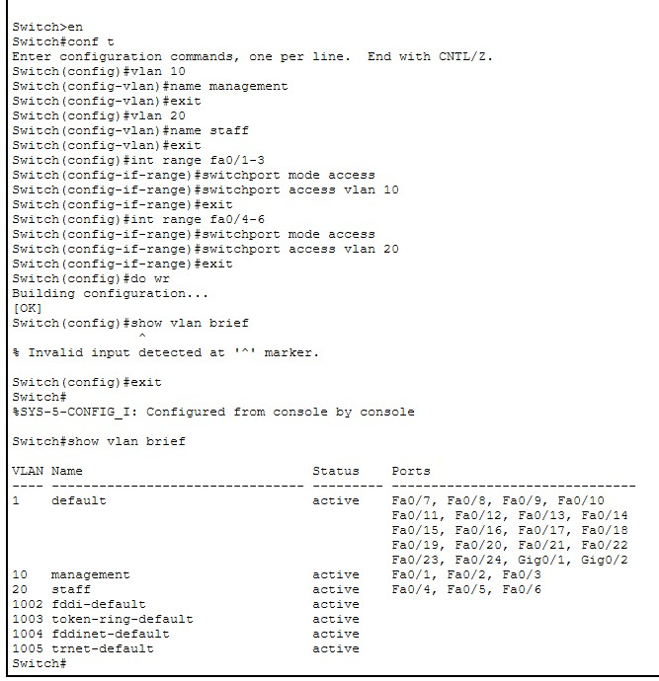

Task 2: Configure an 802.1Q Trunk Link Establish a trunk connection so traffic for multiple VLANs can pass between the switch and router. (Applied — one concept combined with port-mode configuration.) Configure the switch port connecting to the router as an 802.1Q trunk. Restrict the trunk to allow only VLAN 10 and VLAN 20. Verify trunk status using show interfaces trunk. Confirm there is no native VLAN mismatch between the switch and router.
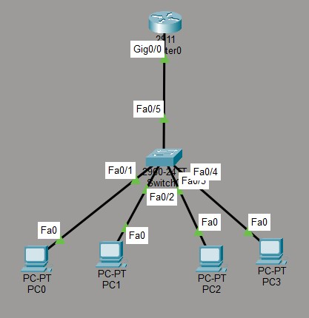
Router
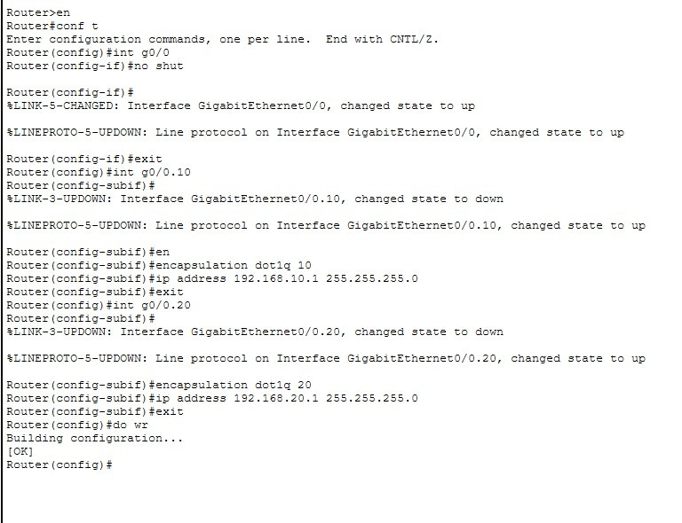

Switch
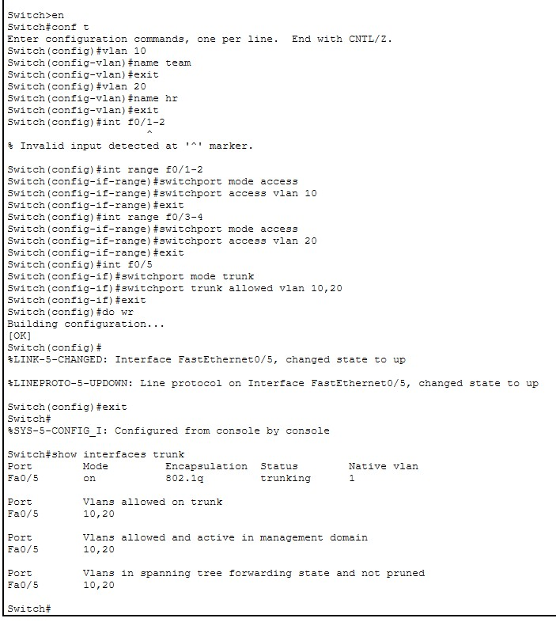

Task 3: Configure Router-on-a-Stick for Inter-VLAN Routing Enable communication between VLAN 10 and VLAN 20 through router sub-interfaces. (Intermediate — two concepts used together: sub-interfacing and routing.) Create two sub-interfaces on the router's trunkconnected interface, one per VLAN. Assign correct IP addressing and 802.1Q encapsulation with the matching VLAN ID on each sub-interface. Enable routing so hosts in VLAN 10 and VLAN 20 can reach each other. Verify connectivity with a successful ping between hosts in different VLANs.
Router
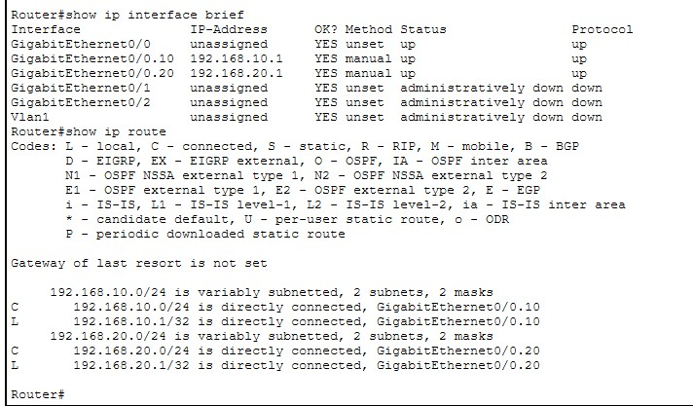
Switch

Verify connectivity

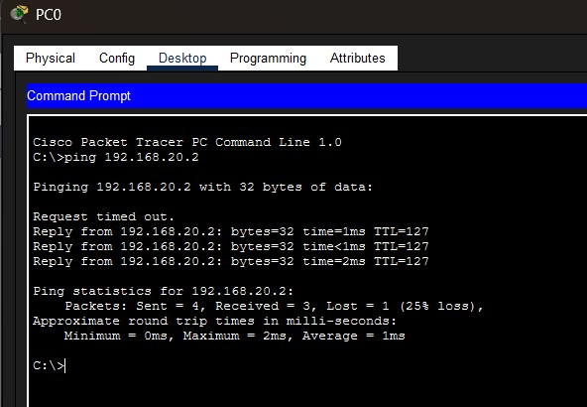

4. Q-Capture and Analyze Inter-VLAN Traffic Use Wireshark to observe how frames change as they cross from switch to router and back. (Integrative — multi-step flow combining VLANs, trunking, and routing.) Capture ICMP traffic while pinging between a VLAN 10 host and a VLAN 20 host. Identify the specific frames that cross the router via the trunk link. Document the source/destination MAC and IP addresses observed at each hop. Explain how the frame headers change as traffic passes from switch to router and back.

To capture and analyze ICMP traffic between a host in VLAN 10 and a host in VLAN 20, observe the traffic as it crosses the switch-router trunk, and document how Layer-2 (MAC/VLAN) headers change while the Layer-3 IP addresses remain end-to-end.
Topology :
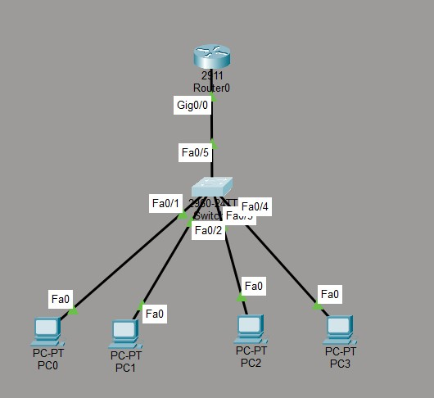

Simulation Filter Configuration
Packet Tracer Simulation Mode was used. ARP and ICMP were selected so that the ICMP Echo Request/Reply traffic could be isolated from unrelated protocols.
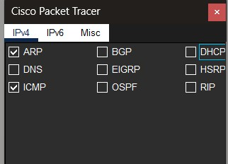

ICMP Capture

After resetting the simulation, an ICMP ping was generated from PC0 to PC2. The Event List shows the ICMP packet moving from PC0 to Switch0, then to Router0, back through Switch0, and finally to PC2. The reverse path carries the ICMP Echo Reply.
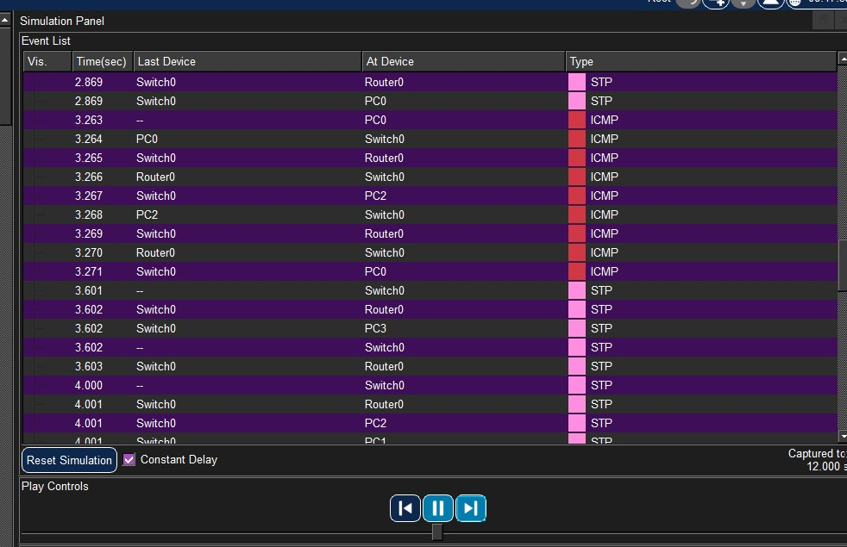

Frame Analysis at the Switch

The Switch0 PDU information shows the Ethernet frame entering the switch and the outgoing frame carrying a Dot1Q header toward the router. This confirms that the switch-router connection is carrying tagged VLAN traffic.

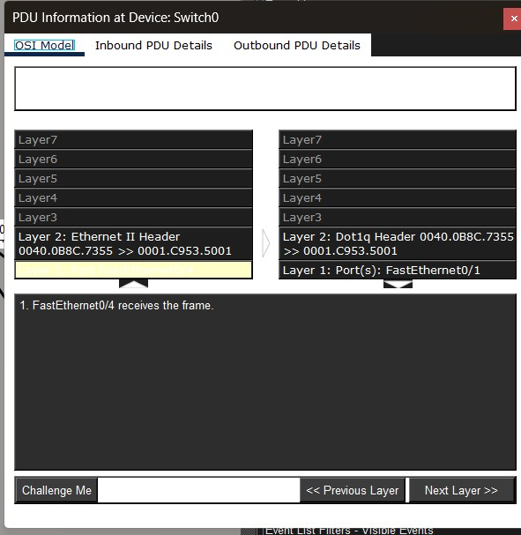

Frame Analysis at Router0

At Router0, the inbound ICMP packet is shown with source IP 192.168.10.2 and destination IP 192.168.20.2. The ICMP message is Type 8, which is an Echo Request. The Layer-2 information is tagged with 802.1Q.
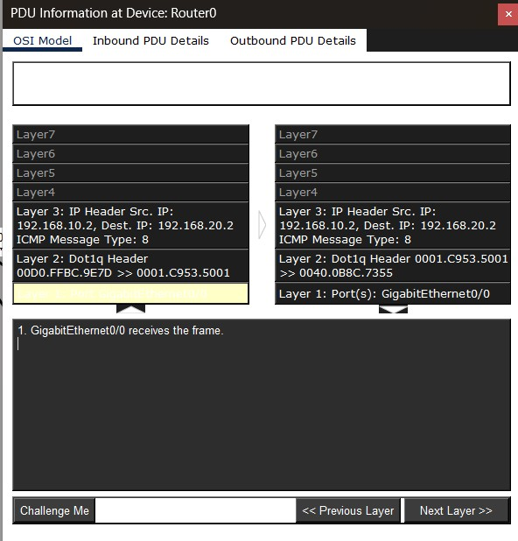

Detailed Inbound 802.1Q and IP Header

The detailed inbound PDU shows TCI = 0x000A. Hexadecimal 0x000A equals decimal 10, therefore the incoming frame is tagged as VLAN 10. The same PDU shows the ICMP packet with source IP 192.168.10.2 and destination IP 192.168.20.2.

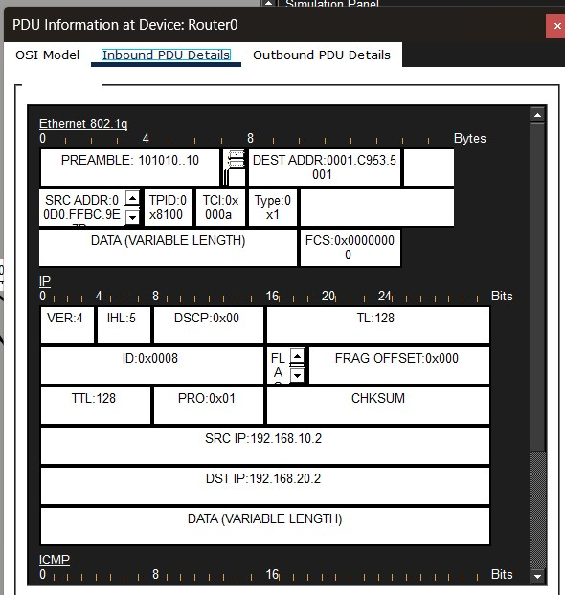

Observed Header Values

The following values are taken directly from the captured Packet Tracer PDU information.

Hop / Frame | Source MAC | Destination  MAC | Source IP | Destination  IP | VLAN / Tag
Switch0 →  Router0  (observed) | 0001.C953.9E7D | 0001.C953.5001 | 192.168.10.2 | 192.168.20.2 | VLAN 10 (TCI 0x000A)
Router0 outbound (observed) | 0001.C953.5001 | 0040.0B8C.7355 | 192.168.10.2 | 192.168.20.2 | Dot1Q shown; outbound VLAN tag value not  visible in  captured screenshot

How the Frame Headers Change
When the ICMP packet travels from VLAN 10 toward VLAN 20, the IP packet is routed by Router0. The Layer-2 Ethernet information is therefore rebuilt for the next Layer-2 segment. The captured values demonstrate that the MAC addresses change across the routed hop, while the source and destination IP addresses remain 192.168.10.2 and 192.168.20.2.

Before / inbound to Router0 | MAC: 0001.C953.9E7D → 0001.C953.5001  IP: 192.168.10.2 → 192.168.20.2  VLAN tag: 10
After / outbound from Router0 | MAC: 0001.C953.5001 → 0040.0B8C.7355  IP: 192.168.10.2 → 192.168.20.2  New Layer-2 frame is created
Main observation | MAC addresses change at the routed hop; IP source/destination remain end-to-end for this ICMP exchange.

The Inter-VLAN ICMP traffic was successfully captured in Cisco Packet Tracer Simulation Mode. The capture shows an 802.1Q-tagged frame entering Router0 on VLAN 10, carrying an ICMP Echo Request from 192.168.10.2 to 192.168.20.2. Router0 routes the packet toward the destination network and creates a new Layer-2 frame, changing the MAC addresses while preserving the endto-end IP addresses. This demonstrates the interaction of VLANs, trunking, Layer-2 switching, and Layer-3 routing.

